Seeing Jesus Again
Psalm 27:8-14
John 1:43-46
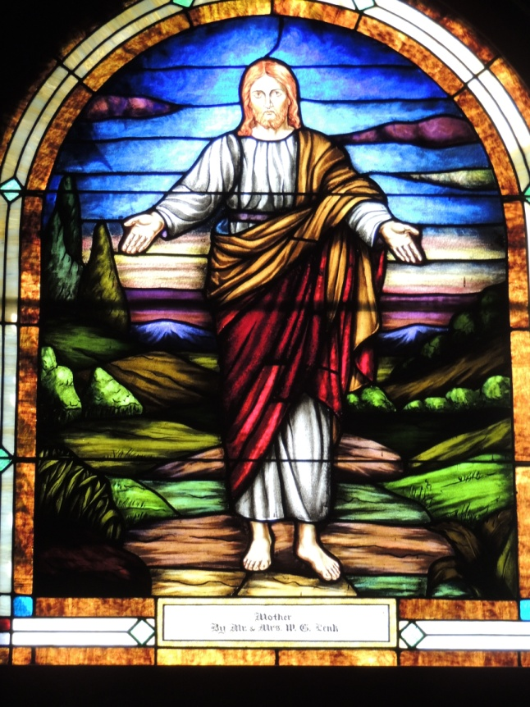
I probably should not make this confession. I know my wife Michele, would say “no, don’t do it.” That’s probably why I never asked her. It was a number of years ago, in the era of Jim Stoll. Those who have been around long enough know that Jim was a faithful, dedicated, long time member of the congregation, who among other things kept a close eye on the church. At the time we had a Christian flag and a U.S. flag in the corners of the front of the sanctuary. Jim and I shared a preference for removing the flags. I am not sure why Jim thought we should remove them. I think for him it was mostly aesthetic. It looked cluttered having the flags up front. My reasons were more theological. I found it troubling to have a symbol of nationalism at the center of worship and I found it troubling to have Christianity, represented by a flag, which too often has been associated with colonialism and Christian imperialism.
In case you are wondering, I haven’t gotten to the part yet where Michele would say, “you shouldn’t really tell that.” The decision had been made to carpet the sanctuary. In order to carpet the sanctuary everything had to be removed, including the flags. When the time came for putting things back, Jim and I looked at each other, and more or less agreed that we would not put the flags back and see what happened. No one noticed. It was like that for a year and half, when suddenly one of the other long time members said, “where are the flags? Who took the flags?” Before you knew it we had a petition to the Council insisting the flags be put back, which they were. How they eventually found their way out of the sanctuary is another story for another day.
Maybe you would agree with Michele, I shouldn’t have told that story. After all who wants a sneaky pastor? I mention it because this morning and for the next number of weeks we will be inviting you to intentionally notice and look at our stained glass Jesus. Like those flags our stained glass Jesus has a way of fading into the background, so that one can worship here, Sunday in and Sunday out and never really notice Jesus. Let me show you what I mean. I want all of you to close your eyes. No peaking. Now, with your eyes closed, what colors are in the garments Jesus is wearing? Now open your eyes. How many of you knew all three colors?
Our focus on Jesus is in part occasioned by some of our members noticing that our stained glass Jesus is quite white. As a Palestinian Jew, it is unlikely Jesus looked anything like what is represented in our window. More likely, he was dark haired and dark skinned in appearance. Ours is a congregation that has a deeply rooted commitment to antiracism. It emerges out of our belief that following Jesus means overcoming those divisions, those barriers that cause so much pain and harm in our world. Antiracism is part of our mission statement. Support for today’s Mendota Mdewakanton POW WOW is part of our antiracism commitment. In a couple months an Overcoming Racism Conference will be held at Metropolitan State University. The last couple years over 400 people were in attendance. That Conference began here at our church. We remain co-sponsors and the Fiscal Agent, partnering with a host of other groups and individuals.
One need only a very limited understanding of racism and how it works to recognize that classifying people into racial groups by skin color is something that has been and is used to benefit those of us who are white. What’s more it is not enough just to say I don’t see skin color, because all those benefits to those of us who are white are already baked into the cake so you get them whether you ask for them or not. What does it mean then to have a white Jesus at the center of our worship for a congregation committed to undoing racism? That’s a challenging question and it is why we have a stained glass Jesus taskforce, who hopefully can guide us into that discussion.
It was our Taskforce’s belief that the best way to have such a conversation, was to open up the question “Who Is Jesus?” Who is Jesus for me? Who is Jesus for you? Who is Jesus for us as a congregation? It is easy to forget that Jesus is even there, even while we gather in worship. Today and in the weeks ahead we are asking you to pay particularly close attention to Jesus, the one in the window and the one in your heart, as we address that question, “Who is Jesus?”.
You have in you your bulletin this morning a sheet of paper with an outline for a cinquain – which is a form of poetry consisting of five very short lines which tell a small story. All the words build on the first. I am going to invite you to look closely at Jesus and then write your own poem based on what you see and experience. You start with a noun on the first line, a couple of descriptive adjectives on the second line, three action (ing) verbs on the third line, a four word comment, and finally a word that is synonymous with the first. When we are done, those who are willing will be invited to share your poem. All of them can be posted on a board in the Fellowship Hall.
I have already lifted up that Jesus is white. What else do you notice? What in our stained glass Jesus captures something of our faith that you would want to affirm and embrace? Imagine you are Nathaniel and have been invited by Philip to come and see for yourself, as if for the first time, who Jesus is. I will give you approximately five minutes.

Who this morning is willing to share your poem? We can bring the mike to you.

Thank you to all who have shared. I invite all of you to post your poems on the designated board in the Fellowship Hall so others might see what you have written. Also, in the Fellowship Hall we have placed on each table books that have a wide diversity of images for Jesus. We will leave them there throughout this series. You are invited to look at them and share with those around you images of Jesus that you find particularly striking and engaging.
Next Sunday, I will show you an image of Jesus from my home town church that was formative in my younger years. The current pastor at Braham Covenant was kind enough to email a picture of the painting. It will be projected on the wall and I will then share with you my own journey with Jesus. On the following Sundays we will draw from the differing portraits of Jesus found in the Gospels, each Sunday looking at a distinctive image that our Gospel writers present. Those images include a portrait of Jesus as a healer and liberator, a portrait of Jesus as a subversive wisdom teacher, a portrait of Jesus as a social prophet and movement founder, and a portrait of Jesus as a mystic, a spirit person. We will conclude with another invitation to do a cinquain poem, but this time with a new image of Jesus. I hope that you are able to be with us as together we engage the question, “Who Is Jesus?”

I close with the quote by Pierre Teilhard de Chardin, which is found at the beginning of your bulletin.
“To see more is to become more.”
Could it be this is what Jesus is seeking for us all?

Psalm 27:8-14
In our first lesson the Psalmist longs to see the face of God. The Psalmist acknowledges that it may at times seem like God is hiding. Yet, the psalmist knows that seeking after God means following the path of God and looking for the goodness of God in the land of the living.

⁸ ‘Come,’ my heart says, ‘seek God’s face!’ Your face, god, do I seek.
⁹ Do not hide your face from me. Do not turn your servant away in anger, you who have been my help. Do not cast me off, do not forsake me, O God of my salvation! ¹⁰ If my father and mother forsake me, the Lord will take me up. ¹¹ Teach me your way, O God, and lead me on a level path because of my enemies. ¹² Do not give me up to the will of my adversaries, for false witnesses have risen against me, and they are breathing out violence. ¹³ I believe that I shall see the goodness of God in the land of the living. ¹⁴ Wait for God; be strong, and let your heart take courage; wait for God!

John 1:43-46
In our Gospel lesson today Philip has encountered Jesus and is convinced Jesus is the One for whom they have been waiting. With excitement Philip finds his friend and Andrew and invites the skeptical Andrew to come and see for himself.

43 The next day Jesus decided to go to Galilee. He found Philip and said to him, ‘Follow me.’ ⁴⁴Now Philip was from Bethsaida, the city of Andrew and Peter. ⁴⁵Philip found Nathanael and said to him, ‘We have found him about whom Moses in the law and also the prophets wrote, Jesus son of Joseph from Nazareth.’ ⁴⁶Nathanael said to him, ‘Can anything good come out of Nazareth?’ Philip said to him, ‘Come and see.’

