Who Is Jesus? – A Personal Journey
Psalm 139
Luke 9:18-20
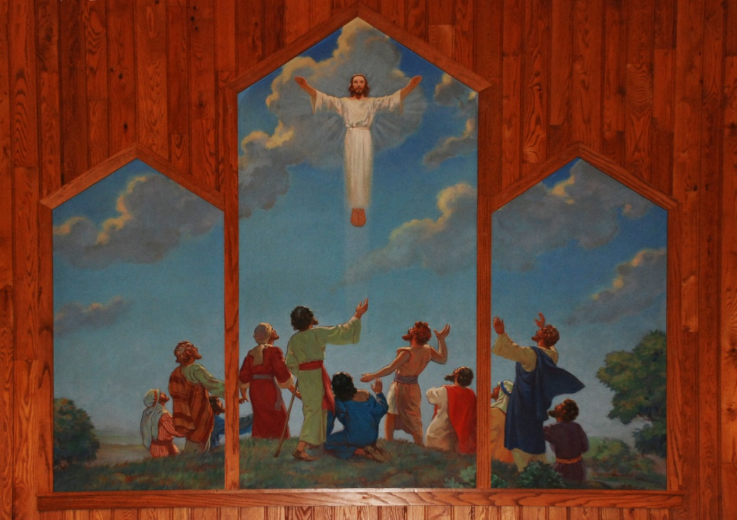
As a child and a young person, the image of Jesus you see projected this morning is the image that I saw every Sunday. It hung directly behind the pulpit, covering much of the wall. For my parent’s and many of the people in Braham Evangelical Covenant Church, the church of my childhood, this image of Jesus ascending to be with God was a literal rendering of what actually happened. If you had been there on the hill, it is what you would have seen. The image was central to their faith. No doubt it remains so for many who worship their today.
But, for me this picture of Jesus hovering over the disciples became a major barrier to experiencing Jesus as anyone with whom I could ever connect or even want to connect. My parents and other church members looked at this image of Jesus ascension and they were assured that no matter what life brought, good or bad, Jesus can help us raise above all those earthly issues. I looked at this very same image and I saw a Jesus who was nothing like me, a Jesus who was more about some distant, way off world and had little to do with the questions and the challenges I knew as a young person.
My parents and other church members saw Jesus rising into the clouds and they were assured that this Jesus points the way to the love of God that will one day reunite them with loved ones they have lost. My parents found tremendous comfort believing that their young son, my brother, killed on a farm accident at the age of four, was welcomed into heaven by the Jesus captured in this image. I on the other hand, found little comfort in this Jesus. Jesus seemed distant and removed from the grief and the loss I felt with my brother’s death and seemed to know nothing about the questions I felt as a teenager. It took me years before I discovered a Jesus with whom I could begin to connect. This image was a real barrier.
How can an image of Jesus be such a source of comfort and hope to some and at the same time be such a road block and barrier to someone else? This, of course, is at the heart of the question with our stained glass Jesus. One person’s comfort can be another person’s road block.
Last Sunday, I noted that our stained glass Jesus probably looks nothing like the Jesus of Palestine, who was most likely dark skinned with dark hair. The same is true of the painting which hung in my hometown church. The painting of Jesus ascending into the heavens was done by a man by the name of Warner Sollman, who was of Swedish descent and a member of the Evangelical Covenant Church. It was Sollman’s head of Christ image that became so popular after World War 11, ultimately being reproduced over 5 million times. You still see his head of Christ image in many churches. Not surprisingly the images Sollman created of Jesus and the disciples as well, look a lot like someone who emigrated from Sweden. They too are quite white.
Unfortunately for Jesus, the association of this light skin color and European facial characteristics with his identity comes with some considerable baggage. Although generally ignored or minimized in most telling of U.S. history, there is absolutely no doubt that again and again white skin color has been used to justify slavery, justify the genocide of Indigenous people, justify the theft of Mexican land, justify colonialism of Puerto Ricans, Pilipinos and many others. Whiteness, which is more than skin color, but also includes the belief in the primacy of Western culture, literature, music, family and community norms, has been used and continues to be used as a way of saying one group of people is superior to another group of people. Some of us look at a white skinned Jesus with open arms and see a welcome and others see a Jesus loaded up with all the baggage of exploitation and oppression that is unquestionably a part of our history.
The Jesus of my childhood was a tremendous source of comfort and hope for my parents. I would never wish to take that away from them. But, at the same time, I have to be honest this very same Jesus was a spiritual road block for me. Who Is Jesus? This is no easy question for us as individuals or as a community of faith. The Psalmist after all reminds us knowledge of spiritual truths “is too wonderful for me, it is so high that I cannot attain it.” Or to put it just a little differently, certainty about God or about Jesus is out of our reach. This is why Jesus poses the question to the disciples and to us “Who do you say that I am?” Rather than a one-time response, given early in life and then set aside, it is a question Jesus continues posing throughout our lives. Now that you are a teenager who do you say that I am? Now that you are in your thirties, forties, seventies, eighties, who do you say that I am? This is no one time pass the final exam question. This is a journey question, asked again and again and again. Who do you say that I am?
Fortunately, when it comes to portraits of Jesus and our response to this question we have the Gospels as our model. Matthew, Mark and Luke each paint a different portrait of Jesus. They have no intention of coming up with one singular dominant way of showing us who Jesus is. Each of them gets out their canvas and paints a different picture, one that most clearly represents what they believe is central to who Jesus is.
Their canvas, of course, takes the form of weaving together stories about Jesus in a way that provides a narrative about Jesus’ life. But, make no mistake; it is the intention of Matthew, Mark, Luke and John to create an image in our minds and in our hearts about who Jesus is. Mark is the earliest of the portraits created and was developed some 30 to 40 years after Jesus has been executed by Roman powers. Matthew and Luke create their pictures of Jesus some 20 years or so after Mark. Scholars agree both Matthew and Luke had a look at Mark’s portrait as well as another portrait painted by a person known simply as Q. Each of them, however, have their own distinctive way of presenting Jesus. Only Matthew and Luke give us a picture of Jesus as a baby. Mark and John have no such picture. John is the last one to create a picture of Jesus, painting his image some 70 to 80 years after Jesus has been killed. There were, of course, other images of Jesus that people created. But, these four are the ones the church ultimately settled on as being the best example of how we too might go about answering the question of who Jesus is for us. In the coming weeks we will be looking at portraits of Jesus created by each of the Gospels.
It is never the intention of the Gospel portrait painters to create an image of Jesus that is the singular correct image. In many respects the Gospels painters are more like the movie producers who created the recent movie “Lee Daniels, The Butler.” The Butler tells the true story of an African American man who served as the butler for six U.S. Presidents, covering a large scope of U.S. racial history. If you have seen the movie or read about the movie than you may know that not every scene in the movie is literally true. The butler, for example, never had a son who became affiliated with the Black Panthers. But, while there are parts of the story that are not literally true, they still tell a truth about the racial history of the U.S. This is how the Gospels were created. Gospel writers are seeking to create an image of Jesus that is true to who they believe Jesus is. They may not be literally true, but they tell a truth about Jesus.
Perhaps the one thing on which all the Gospels agree is that through Jesus we get a glimpse of what God is like. It, therefore, matters a great deal how we answer the question, “Who do you say that I am?” It is the affirmation of the church that it is the life of Jesus through which we are given a picture of the One who as the Psalmist says, “searches out our path and our lying down and is acquainted with all our ways”.
Although, the portrait of Jesus that hung in the front of the sanctuary in my hometown church was for me a spiritual roadblock and hindrance, there is a dimension of that image which I would resoundingly affirm. Lifted up above the disciples, hung between heaven and earth, this image of Jesus said to my parents, as it says to me “the love of God” is wider and deeper than all human imagining.
“Who do you say that I am?” It is a life-long question with which we are invited and encouraged to reflect and respond. My own journey has taken me to a place where rather than see Jesus as a distant, semi-human, other world being, I now see Jesus as a companion, a guide a teacher who risks everything, including his life for the sake of God’s love and God’s justice. That is my developing portrait. It may not be yours. Over the coming Sundays we will add to the possible portraits of Jesus with images we find in the Gospels of Matthew, Mark, Luke and John. But, even those images, those portraits, are limited, keeping alive the question for each of us, “who is Jesus?”
This is, of course, is a journey question for you, for me, for us as a congregation. We have choices to make as we answer that question, as we create our portrait of Jesus. Some of those preferences may be an affirmation for some of us, while a huge barrier for others. We will do well to listen to each other. I close this morning with a quote found on the top of your bulletin.

There comes a time in the spiritual journey when you start
making choices from a very different place….And if a choice
lines up so that it supports truth, health, happiness, wisdom,
and love. It is the right choice.

Psalm 139
In our first lesson the Psalmist affirms the presence of God in all creation and all of life. There is nowhere we might go or be where God is absent. We are always surrounded by the presence and love of God. Yet, even while the Psalmist affirms God’s presence, the Psalmist insists the love and presence of God is always beyond our human understanding.

¹ O Lord, you have searched me and known me. ² You know when I sit down and when I rise up; you discern my thoughts from far away. ³ You search out my path and my lying down, and are acquainted with all my ways. ⁴ Even before a word is on my tongue, O Lord, you know it completely. ⁵ You hem me in, behind and before, and lay your hand upon me. ⁶ Such knowledge is too wonderful for me; it is so high that I cannot attain it. ⁷ Where can I go from your spirit? Or where can I flee from your presence? ⁸ If I ascend to heaven, you are there; if I make my bed in Sheol, you are there. ⁹ If I take the wings of the morning and settle at the farthest limits of the sea, ¹⁰ even there your hand shall lead me, and your right hand shall hold me fast. ¹¹ If I say, ‘Surely the darkness shall cover me, and the light around me become night’,¹² even the darkness is not dark to you; the night is as bright as the day, for darkness is as light to you.

Luke 9:18-20
The Gospels never hesitate to present the humanity of the disciples, including their constant struggle to understand who Jesus is. Their challenge is our challenges as well and so Jesus poses a question for all times, “Who do you say that I am?”

Once when Jesus was praying alone, with only the disciples near him, he asked them, ‘Who do the crowds say that I am?’ They answered, ‘John the Baptist; but others, Elijah; and still others, that one of the ancient prophets has arisen.’ He said to them, ‘But who do you say that I am?’

