Vigilance for Communities of Faith

Presenters

Okogyeamon, PhD, Cherokee Park United Church, Antiracism Team

Dr. Tim Johnson, Pastor, Cherokee Park United Church, Antiracism Team

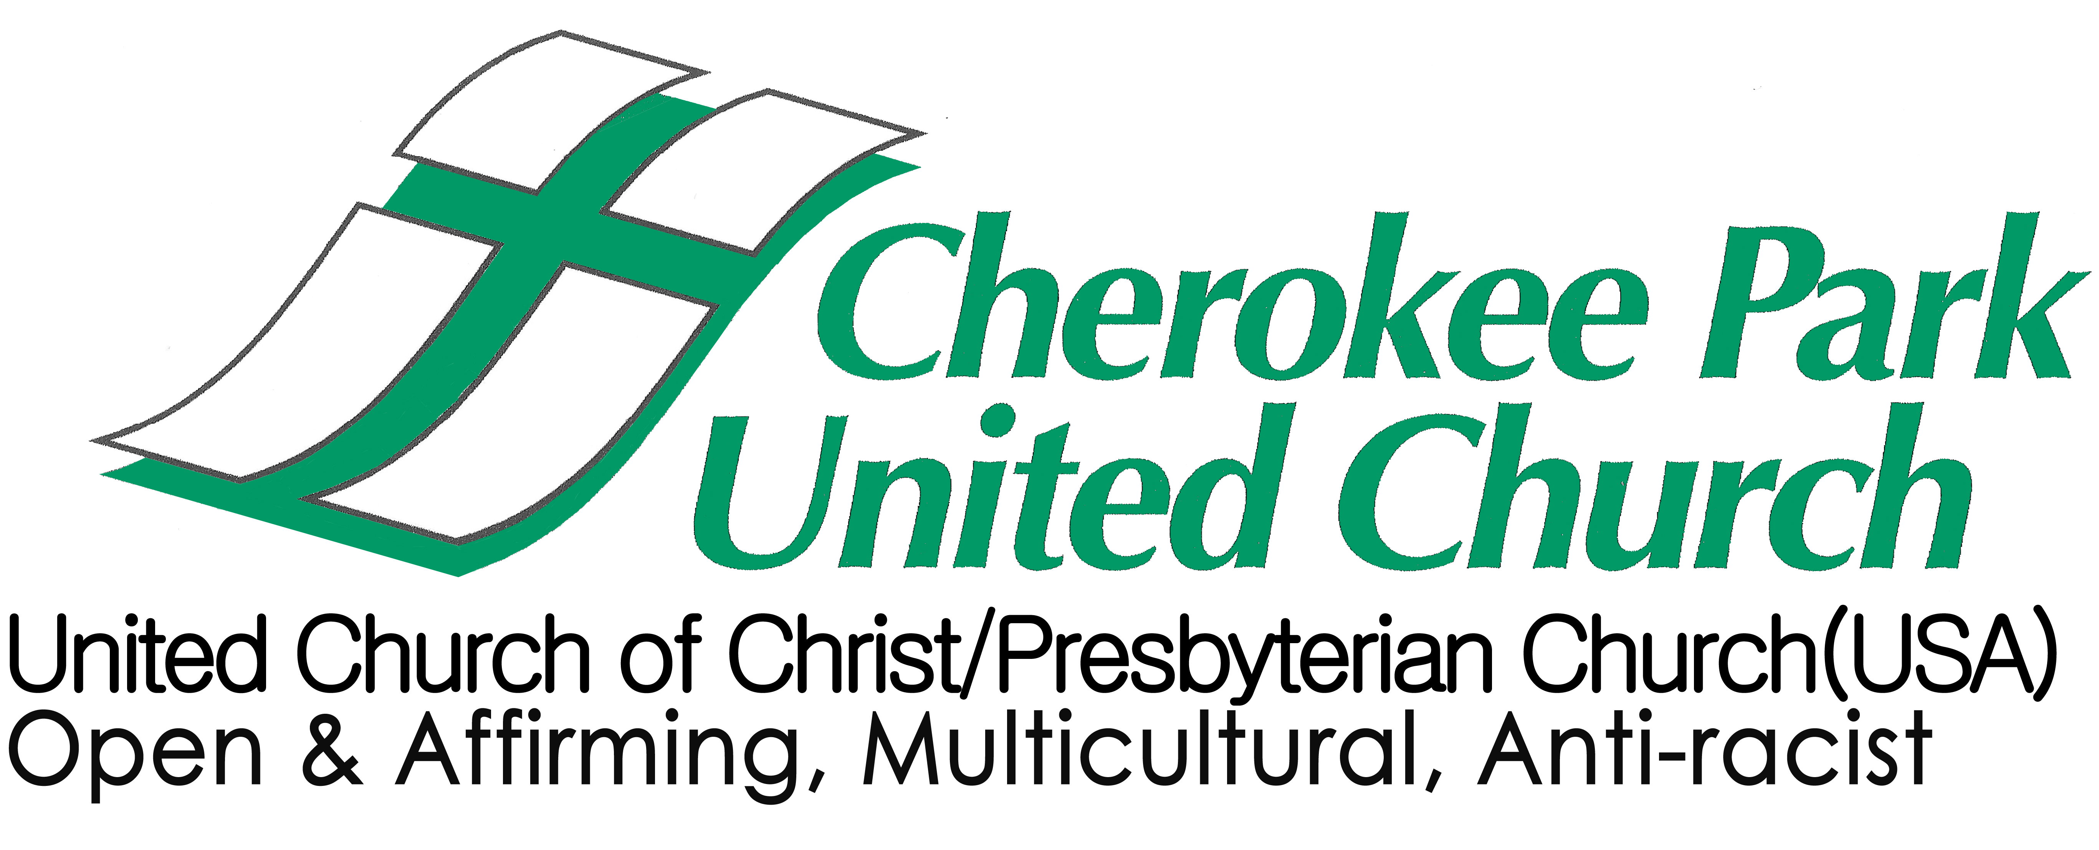
371 West Baker St.
St. Paul, MN 55107

http://www.cherokeeparkunited.org/antiracism/antiracism-learning-resources/

Justice and Antiracism Vigilance
Foundation for Vision

A vision creates a personal responsibility to carry out its directive.
from Reclaiming Indigenous Voices by Marie Battiste

Isaiah 25:6-10
6 On this mountain the Lord of hosts will make for all peoples a feast of rich food, a feast of well-matured wines, of rich food filled with marrow, of well-matured wines strained clear. 7 And he will destroy on this mountain the shroud that is cast over all peoples, the sheet that is spread over all nations; 8 he will swallow up death for ever. Then the Lord God will wipe away the tears from all faces, and the disgrace of his people he will take away from all the earth, for the Lord has spoken. 9 It will be said on that day, Lo, this is our God; we have waited for him, so that he might save us. This is the Lord for whom we have waited let us be glad and rejoice in his salvation. 10 For the hand of the Lord will rest on this mountain.

Luke 13:29-30
29Then people will come from east and west, from north and south, and will eat in the kingdom of God. 30Indeed, some are last who will be first, and some are first who will be last.’

Mark 10:13-15
13 People were bringing little children to him in order that he might touch them; and the disciples spoke sternly to them. 14But when Jesus saw this, he was indignant and said to them, ‘Let the little children come to me; do not stop them; for it is to such as these that the kingdom of God belongs. 15Truly I tell you, whoever does not receive the kingdom of God as a little child will never enter it.’ 16And he took them up in his arms, laid his hands on them, and blessed them.

QUESTIONS
What is the shared vision of your community?

What vision does your community have for a just/racist free world? What does that world look like?

What sacred texts, stories, or readings provide the foundation for this vision?

How might a vision that includes antiracism help your community remain vigilant in the work of antiracism?

*See “Antiracism: Critical Concepts & Tools…” & “A Congregation Committed….”
Wall Hanging in the Fellowship Hall of Cherokee Park United Church
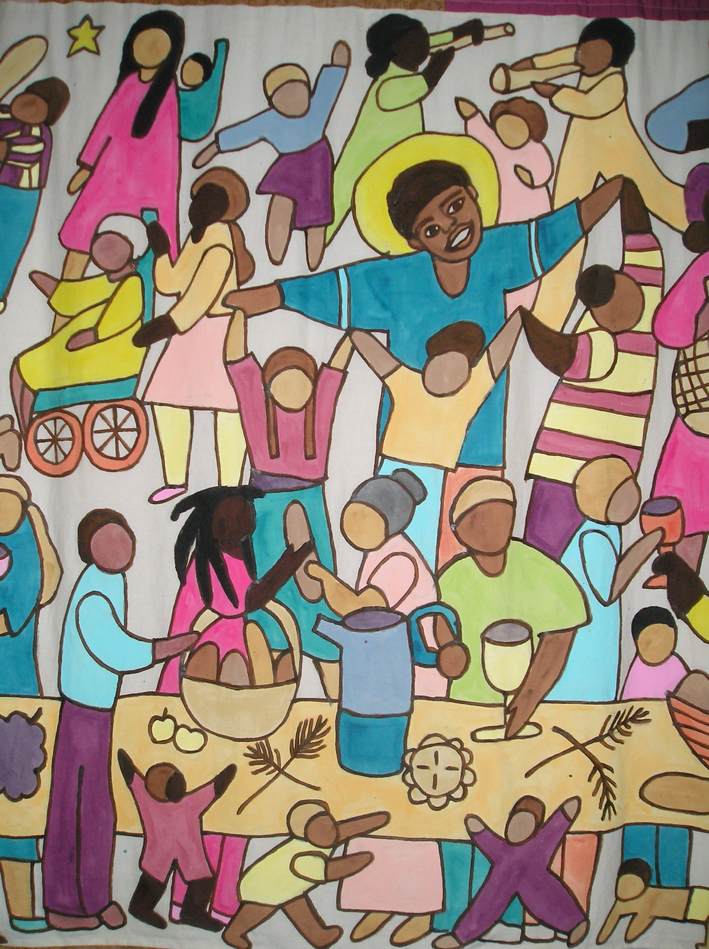
Justice and Antiracism Vigilance

A Foundation for Mission

The image of the passionless Christian – the sweet, saccharin, flaccid, and passive
participant in life – is not worthy of the ideals of Christianity.
from the Psalms by Joan Chittister

Those who live without passion lack bite, lack force, lack fullness of life.
from Angels of Grace by Anselm Gruen

Isaiah 51.4:
Listen to me, my people, and give heed to me, my nation; for a teaching will go out from me, and my justice for a light to the peoples.

Micah 6.8:
He has told you, O mortal, what is good; and what does the Lord require of you but to do justice, and to love kindness, and to walk humbly with your God?

Luke 4
18 The Spirit of the Lord is upon me, because he has anointed me to bring good news to the poor. He has sent me to proclaim release to the captives and recovery of sight to the blind, to let the oppressed go free, 19 to proclaim the year of the Lord’s favor.

Luke 9.2:
… he sent them out to proclaim the kingdom of God and to heal

QUESTIONS
How does your community understand its mission? What is the calling/purpose of your community?

How might antiracism be seen as central to the mission/calling/purpose of your community?

What sacred texts, stories, or readings provide the foundation for this mission?

How might a commitment to antiracism in your mission help your community remain vigilant?

*See “Definitions: Antiracism, and White Racial Frame”

Mission Statement for Cherokee Park United Church
Cherokee Park United Church is called to a life of compassionate justice
and to embody the boundless love of Jesus.
We confess that communities of faith have not always
celebrated the dignity and joyful diversity of all God’s creation.
Therefore, we declare Cherokee Park United Church to be an inclusive,
multicultural, antiracist, justice-seeking,
environmentally responsible community of faith.
We seek a new humanity where sexual orientation,
age, gender, culture or differing abilities are no longer a barrier
to our living in just relationship.
To fulfill our mission we will turn to
the Holy Spirit and to each other with our questions
and for our answers.

A Foundation for Justice and Antiracism Vigilance
Additional Vision and Mission Texts

Psalm 140:12, 13
12 I know that the Lord maintains the cause of the needy, and executes justice for the poor.
13 Surely the righteous shall give thanks to your name; the upright shall live in your presence.

Psalm 146:5-9
5 Happy are those whose help is the God of Jacob, whose hope is in the Lord their God, 6 who made heaven and earth, the sea, and all that is in them; who keeps faith for ever; 7 who executes justice for the oppressed; who gives food to the hungry. The Lord sets the prisoners free; 8 the Lord opens the eyes of the blind. The Lord lifts up those who are bowed down;
the Lord loves the righteous. 9 The Lord watches over the strangers; he upholds the orphan and the widow, but the way of the wicked he brings to ruin.

Isaiah 1:17
learn to do good; seek justice, rescue the oppressed, defend the orphan, plead for the widow.

Isaiah 30:18
Therefore the Lord waits to be gracious to you; therefore he will rise up to show mercy to you.
For the Lord is a God of justice; blessed are all those who wait for him.

Isaiah 32:16
Then justice will dwell in the wilderness, and righteousness abide in the fruitful field.

Isaiah 42:1-6
Here is my servant, whom I uphold, my chosen, in whom my soul delights; I have put my spirit upon him; he will bring forth justice to the nations. 2 He will not cry or lift up his voice, or make it heard in the street; 3 a bruised reed he will not break, and a dimly burning wick he will not quench; he will faithfully bring forth justice. 4 He will not grow faint or be crushed until he has established justice in the earth; and the coastlands wait for his teaching. 5 Thus says God, the Lord, who created the heavens and stretched them out, who spread out the earth and what comes from it, who gives breath to the people upon it and spirit to those who walk in it: 6 I am the Lord, I have called you in righteousness, I have taken you by the hand and kept you;
I have given you as a covenant to the people, a light to the nations,

Isaiah 58.6:
Is not this the fast that I choose: to loose the bonds of injustice, to undo the thongs of the yoke,
to let the oppressed go free, and to break every yoke?

Jeremiah 9:23, 24
23 Thus says the Lord: Do not let the wise boast in their wisdom, do not let the mighty boast in their might, do not let the wealthy boast in their wealth; 24but let those who boast, boast in this, that they understand and know me, that I am the Lord; I act with steadfast love, justice, and righteousness in the earth, for in these things I delight, says the Lord.

Jeremiah 22.3:
Thus says the Lord: Act with justice and righteousness, and deliver from the hand of the oppressor anyone who has been robbed. And do no wrong or violence to the alien, the orphan, and the widow, nor shed innocent blood in this place.

Jeremiah 23.5:
The days are surely coming, says the Lord, when I will raise up for David a righteous Branch, and he shall reign as king and deal wisely, and shall execute justice and righteousness in the land.

Hosea 12.6:
But as for you, return to your God, hold fast to love and justice, and wait continually for your God.

Amos 5:21-24
21 I hate, I despise your festivals, and I take no delight in your solemn assemblies. 22 Even though you offer me your burnt-offerings and grain-offerings, I will not accept them; and the offerings of well-being of your fatted animals I will not look upon. 23 Take away from me the noise of your songs; I will not listen to the melody of your harps. 24 But let justice roll down like waters, and righteousness like an ever-flowing stream.

Matthew 6.33:
But strive first for the kingdom of God and his righteousness, and all these things will be given to you as well.

Matthew 19.24:
Again I tell you, it is easier for a camel to go through the eye of a needle than for someone who is rich to enter the kingdom of God.’

Matthew 21.43:
Therefore I tell you, the kingdom of God will be taken away from you and given to a people that produces the fruits of the kingdom.

Mark 1.15:
and saying, ‘The time is fulfilled, and the kingdom of God has come near; repent, and believe in the good news.’*

Luke 6.20:
Then he looked up at his disciples and said: ‘Blessed are you who are poor, for yours is the kingdom of God.

Luke 9.2:
and he sent them out to proclaim the kingdom of God and to heal.

Luke 9.11:
When the crowds found out about it, they followed him; and he welcomed them, and spoke to them about the kingdom of God, and healed those who needed to be cured.

Luke 13.18-21
18 He said therefore, ‘What is the kingdom of God like? And to what should I compare it? 19It is like a mustard seed that someone took and sowed in the garden; it grew and became a tree, and the birds of the air made nests in its branches.’ 20 And again he said, ‘To what should I compare the kingdom of God? 21It is like yeast that a woman took and mixed in with three measures of flour until all of it was leavened.’

Luke 18.17:
Truly I tell you, whoever does not receive the kingdom of God as a little child will never enter it.’

Matthew 22:37-40
37He said to him, ‘ “You shall love the Lord your God with all your heart, and with all your soul, and with all your mind.” 38This is the greatest and first commandment. 39And a second is like it: “You shall love your neighbor as yourself.” 40On these two commandments hang all the law and the prophets.’

Romans 12.2:
Do not be conformed to this world, but be transformed by the renewing of your minds, so that you may discern what is the will of God—what is good and acceptable and perfect.*

2 Corinthians 5
16 From now on, therefore, we regard no one from a human point of view; even though we once knew Christ from a human point of view, we know him no longer in that way. 17So if anyone is in Christ, there is a new creation: everything old has passed away; see, everything has become new! 18All this is from God, who reconciled us to himself through Christ, and has given us the ministry of reconciliation; 19that is, in Christ God was reconciling the world to himself, not counting their trespasses against them, and entrusting the message of reconciliation to us. 20So we are ambassadors for Christ, since God is making his appeal through us; we entreat you on behalf of Christ, be reconciled to God.

James 2.5-10
5Listen, my beloved brothers and sisters. Has not God chosen the poor in the world to be rich in faith and to be heirs of the kingdom that he has promised to those who love him? 6But you have dishonored the poor. Is it not the rich who oppress you? Is it not they who drag you into court?7Is it not they who blaspheme the excellent name that was invoked over you?
8 You do well if you really fulfill the royal law according to the scripture, ‘You shall love your neighbor as yourself.’ 9But if you show partiality, you commit sin and are convicted by the law as transgressors. 10For whoever keeps the whole law but fails in one point has become accountable for all of it.

Revelation 21.1-5
21Then I saw a new heaven and a new earth; for the first heaven and the first earth had passed away, and the sea was no more. 2And I saw the holy city, the new Jerusalem, coming down out of heaven from God, prepared as a bride adorned for her husband. 3And I heard a loud voice from the throne saying, ‘See, the home of God is among mortals. He will dwell with them; they will be his peoples, and God himself will be with them; 4 he will wipe every tear from their eyes.
Death will be no more; mourning and crying and pain will be no more, for the first things have passed away.’ 5 And the one who was seated on the throne said, ‘See, I am making all things new.’
A Foundation for Antiracism Vigilance
Social Justice and Sociological Foundations

What Vigilance Requires of Us: Repair the Broken Walls

Isaiah 58:12. Your sons and daughters will rebuild the cities that were destroyed long ago. And you will build again on the old foundations. You will be called, One Who Repairs Broken Walls. You will be called, One Who Makes City Streets Like New Again. (NIRV)

Requirements of vigilance call communities of faith to attend to the hidden trap of making “reconciliation” the goal of social justice or conceiving of it as an adequate means to realizing the vision of the beloved community. For, reconciliation cannot be had without the prior work of reparation, repairing what is wrong with race relations. What is wrong with race relations is racism, the legacy received and active in all aspects of our lives, in all institutions, including the church.

Reconciliation cannot be had until we address the underlying causes of race-separation and make repair. We cannot repair what we do not first understand to be broken. We start, then, with an open-eyed understanding that we live in a state of brokenness and separation. After acknowledging that, we need to ask, Why is that so? What brought us to this place of separation and alienation and keeps us here? What history? What particulars in that history created injury? We ask, What harm (material and spiritual) the injury itself caused and continues to cause? We need to ask, What ways of conceiving who we are and who the Other is contributes to ongoing separation – what values espoused, what images and beliefs held contributes to racial estrangement? But especially, we need to examine our practices – racial practices that continue to uphold and maintain unjust social arrangements and systems of rewards and distribution of social goods (material, psychological, and spiritual).

Vigilance requires a reexamination of our frames of understanding (our paradigms). Reconciliation has been a central value and frame of understanding for Christians. However, reconciliation absent reparation (repair) has not worked. It must be reexamined.

In an accompanying essay, you’ll find the remaining sections of the discussion begun here. That essay, modified and re-ordered of excerpts of material from Jennifer Harvey 2014, Dear White Christians: For those Still Longing for Racial Reconciliation. In the essay, Harvey fully explicates the concept, “reconciliation.” She shows how the concept is inadequate, and then draws lines connecting reconciliation to universalism. From there, she argues that we need to attend to the historical and contemporary “particulars” that have created the US racial predicament. From there, Harvey helps to see the work needed at this time is repair (reparations). With that work underway, Harvey gives us hope for the possibility of reconciliation and even, perhaps, forgiveness. We invite you to read the entire essay.

Leviticus 25:10-13
10And you shall hallow the fiftieth year and you shall proclaim liberty throughout the land to all its inhabitants. It shall be a jubilee for you: you shall return, every one of you, to your property and every one of you to your family. 13 In this year of jubilee you shall return, every one of you, to your property. .

Isaiah 61;1-4
61The spirit of the Lord God is upon me,
because the Lord has anointed me;
he has sent me to bring good news to the oppressed,
to bind up the broken-hearted,
to proclaim liberty to the captives,
and release to the prisoners;
2 to proclaim the year of the Lord’s favor,
and the day of vengeance of our God;
to comfort all who mourn;
3 to provide for those who mourn in Zion—
to give them a garland instead of ashes,
the oil of gladness instead of mourning,
the mantle of praise instead of a faint spirit.
They will be called oaks of righteousness,
the planting of the Lord, to display his glory.
4 They shall build up the ancient ruins,
they shall raise up the former devastations;
they shall repair the ruined cities,
the devastations of many generations.

Luke 4:18-19
18 ‘The Spirit of the Lord is upon me,
because he has anointed me
to bring good news to the poor.
He has sent me to proclaim release to the captives
and recovery of sight to the blind,
to let the oppressed go free,
19 to proclaim the year of the Lord’s favour.

QUESTIONS:

- What do you understand by “reconciliation”? What would that look like?

2. What sacred texts or stories in your community and tradition provide a foundation for reparation?

3. How would the “material” conditions be different through achieving the conciliation that you
propose?

4. What particular work of “repair” would you and your congregation be working on in order to be in
position to engage a reconciliation ministry?

5. What do you understand by the concept of “universalism”? What are examples of universalism as it
might be found in the way people are treated? Or, the opportunities available to them?

6. What does universality espouse? What value lies behind it?

7. Does your congregation hold “universalism” as a core value? Where do you see it manifested? What
are the possible consequences of your behaving toward others and expecting them to respond to your
overtures in terms consistent with “universalism”? Could universalism be problematic? In what ways?

8. How might “universalism” be connected to the “white racial frame”? What do you understand by the
“white racial frame”? Is reconciliation possible without addressing with the “white racial frame”?
Explain.

9. How does “antiracism” or an antiracism agenda or antiracism curriculum speak to the issues
associated with the “white racial frame”? How might it address issues of repair?

*See also, “What Vigilance Requires of Us: Repair the Broken Walls”, “White Racial Frame: Historical and Contemporary” & “White Christians: Remember Black Power?”, “Undoing the Violence….”

Educate

Values & Text

Journey - Growing

“The whole idea of journey is basic to humanity…Christian discipleship asks of us to follow a man who had nowhere to lay his head. Christ himself is the Way and is followers are people of the Way. Just has he entered the wilderness, like Moses and the Children of Israel, and made his own journey through life to death and resurrection and new life, so that pattern is inescapable for us all…This journey will be costly and the Celtic tradition never allows us to forget just how costly…For the really significant journey is the interior journey.
From the Celtic Way of Prayer by Esther DeWaal

Genesis 12.1-4, 9:
12Now the Lord said to Abram, ‘Go from your country and your kindred and your father’s house to the land that I will show you. 2I will make of you a great nation, and I will bless you, and make your name great, so that you will be a blessing. 3I will bless those who bless you, and the one who curses you I will curse; and in you all the families of the earth shall be blessed. 4 So Abram went, as the Lord had told him; and Lot went with him. 9And Abram journeyed on by stages towards the Negeb.

Exodus 13.17, 21, 22:
Exodus 13:17 When Pharaoh let the people go, God did not lead them by way of the land of the Philistines, although that was nearer; for God thought, ‘If the people face war, they may change their minds and return to Egypt.’ .21The Lord went in front of them in a pillar of cloud by day, to lead them along the way, and in a pillar of fire by night, to give them light, so that they might travel by day and by night. 22Neither the pillar of cloud by day nor the pillar of fire by night left its place in front of the people.

Wisdom of Solomon 18.3:
Therefore you provided a flaming pillar of fire as a guide for your people’s unknown journey,
and a harmless sun for their glorious wandering.

Mark 6.7-8:
7He called the twelve and began to send them out two by two, and gave them authority over the unclean spirits. 8He ordered them to take nothing for their journey except a staff; no bread, no bag, no money in their belts;

Wisdom – Learning

The mouths of the righteous utter wisdom, and their tongues speak justice.

Psalm 37.30:

Puzzlement is the beginning of wisdom

Erich Fromm

Psalm 49.3:

My mouth shall speak wisdom; the meditation of my heart shall be understanding.

Psalm 51.6:

You desire truth in the inward being; therefore teach me wisdom in my secret heart.

Ecclesiastes 4:24
24 For wisdom becomes known through speech, and education through the words of the tongue.

Proverbs 1.2-6:
² For learning about wisdom and instruction, for understanding words of insight, ³ for gaining instruction in wise dealing, righteousness, justice, and equity; ⁴ to teach shrewdness to the simple, knowledge and prudence to the young— ⁵ let the wise also hear and gain in learning,
and the discerning acquire skill, ⁶ to understand a proverb and a figure, the words of the wise and their riddles.

Proverbs 4.7:
⁷ The beginning of wisdom is this: Get wisdom, and whatever else you get, get insight.

Proverbs 14.33:
Wisdom is at home in the mind of one who has understanding, but it is not known in the heart of fools.

Isaiah 11.1-5:
A shoot shall come out from the stock of Jesse, and a branch shall grow out of his roots.
² The spirit of the Lord shall rest on him, the spirit of wisdom and understanding, the spirit of counsel and might, the spirit of knowledge and the fear of the Lord. ³ His delight shall be in the fear of the Lord. He shall not judge by what his eyes see, or decide by what his ears hear;
⁴ but with righteousness he shall judge the poor, and decide with equity for the meek of the earth; he shall strike the earth with the rod of his mouth, and with the breath of his lips he shall kill the wicked. ⁵Righteousness shall be the belt around his waist, and faithfulness the belt around his loins.

Luke 2.40:
The child grew and became strong, filled with wisdom; and the favor of God was upon him.

Examples: Places where antiracism education happens @ Cherokee Park United Church
- Preaching
- Liturgy
- Adult Discussion Group – The Cross & the Lynching Tree by James Cone; Dare We Speak of Hope by Allan Boseak, Can I Get A Witness by Brian Blount, Courage to Think Differently by George S. Johnson, Becoming an Anti-racist Church by Joseph Barndt
- Confirmation for youth
- Sunday School/Nursery – Choice of Books, Images
- Art – hosting exhibits for Artists of Color, Ethnic Images of Jesus projected each Sunday
- Retreats
- Community Forums/Panels – 2 day Antiracism Leadership event, Truth Telling Forums on Minnesota’s Treatment of the Dakota, 2 part event on Doctrine of Discovery, Challenging Biblical Texts of Genocide, Immigration Justice Forum, Colonialism in Context, Racism in Public Art
- Conversations on White Stained Glass Jesus

QUESTIONS
What sacred text/ traditions and values in your community encourage antiracism education?

What are the places in your community life where antiracism education might occur?

How a commitment to educate help your community remain vigilant in the work of antiracism?

*See: Notes on Antiracism Theologies and the White Racial Frame”

Celebrate

Values & Text

Joy & Rejoicing

A joyful heart is the inevitable result of a heart burning with love.
Sister Theresa
Joy is the holy fire that keeps our purpose warm and our intelligence aglow…
Joy shall be reflected in all things.
from Don’t Miss the Miracle by Helen Keller

Psalm 32.11:
Be glad in the Lord and rejoice, O righteous, and shout for joy, all you upright in heart.

Psalm 90.14:
Satisfy us in the morning with your steadfast love, so that we may rejoice and be glad all our day

Psalm 97.12:
Rejoice in the Lord, O you righteous, and give thanks to his holy name!

Isaiah 35
The wilderness and the dry land shall be glad, the desert shall rejoice and blossom; like the crocus 2 it shall blossom abundantly, and rejoice with joy and singing. 5 Then the eyes of the blind shall be opened, and the ears of the deaf unstopped; 6 then the lame shall leap like a deer,
and the tongue of the speechless sing for joy. For waters shall break forth in the wilderness, and streams in the desert; 10 And the ransomed of the Lord shall return, and come to Zion with singing; everlasting joy shall be upon their heads; they shall obtain joy and gladness,
and sorrow and sighing shall flee away.

Jeremiah 31.13:
Then shall the young women rejoice in the dance,\ and the young men and the old shall be merry.
I will turn their mourning into joy, I will comfort them, and give them gladness for sorrow.

John 15.11:
I have said these things to you so that my joy may be in you, and that your joy may be complete.

John 17.13:
But now I am coming to you, and I speak these things in the world so that they may have my joy made complete in themselves.*

Romans 12.12:
Rejoice in hope, be patient in suffering, persevere in prayer.

Romans 14.17:
For the kingdom of God is not food and drink but righteousness and peace and joy in the Holy Spirit.

Romans 15.13:
May the God of hope fill you with all joy and peace in believing, so that you may abound in hope by the power of the Holy Spirit.

Corinthians 1:11-12
11May you be made strong with all the strength that comes from his glorious power, and may you be prepared to endure everything with patience, while joyfully12giving thanks to the Father, who has enabled you to share in the inheritance of the saints in the light.

James 1.2-4
2 My brothers and sisters, whenever you face trials of any kind, consider it nothing but joy, 3because you know that the testing of your faith produces endurance; 4and let endurance have its full effect, so that you may be mature and complete, lacking in nothing.

Examples: Ways in which joy is a part of antiracism work at Cherokee Park United Church
- Antiracism Team meetings – begin with meals, fellowship, sharing and laughter
- Worship – weekly songs of justice a regular part of worship life
- Annual MLK joint worship
- Annual worship service celebrating Monsignor Oscar Romero.
- Community Forums with an emphasis on hospitality and time for fellowship
- Boycott Blues – Puppet theatre production commemorating Rosa Parks
- A Beloved Community evening celebration
- An annual authentic Mardi-Gras celebration.
- Participate in the Cinco de Mayo parade

QUESTIONS
What sacred text/resources and values in your tradition bring a spirit of rejoicing into the work of antiracism?

What are the places in your community life where you might celebrate the work of antiracism?

What role might celebration play in your communities capacity to remain vigilante with its antiracism commitment?

*See Flyers “Mardi Gras Celebration” “Pizza and Puppets”
Agitate

Values & Text

Prophetic Witness

In silence we hear God’s whisper moving like a feather through our being,
stroking and transforming timid souls into a fiery passion for justice.
from A Mystical Heart by Edwin Gately

To the prophet a minor, commonplace sort of injustice assumes almost cosmic proportions.
from I Asked for Wonder by Abraham Joshua Heschel

Exodus 7.1-2
7The Lord said to Moses, ‘See, I have made you like God to Pharaoh, and your brother Aaron shall be your prophet. 2You shall speak all that I command you, and your brother Aaron shall tell Pharaoh to let the Israelites go out of his land.

Deuteronomy 16.19:
19You must not distort justice; you must not show partiality; and you must not accept bribes, for a bribe blinds the eyes of the wise and subverts the cause of those who are in the right.20Justice, and only justice, you shall pursue, so that you may live and occupy the land that the Lord your God is giving you.

Deuteronomy 24.17:
You shall not deprive a resident alien or an orphan of justice; you shall not take a widow’s garment in pledge.

Psalm 82.3-4:
3 Give justice to the weak and the orphan; maintain the right of the lowly and the destitute.
4 Rescue the weak and the needy; deliver them from the hand of the wicked.’

Psalm 89.14:
Righteousness and justice are the foundation of your throne; steadfast love and faithfulness go before you.

Psalm 106.3:
Happy are those who observe justice, who do righteousness at all times.

Psalm 140.12:
I know that the Lord maintains the cause of the needy, and executes justice for the poor.

Isaiah 42.1-4:
Here is my servant, whom I uphold, my chosen, in whom my soul delights; I have put my spirit upon him; he will bring forth justice to the nations. 2 He will not cry or lift up his voice, or make it heard in the street; 3 a bruised reed he will not break, and a dimly burning wick he will not quench; he will faithfully bring forth justice. 4 He will not grow faint or be crushed until he has established justice in the earth; and the coastlands wait for his teaching.

Jeremiah 22.3:
Thus says the Lord: Act with justice and righteousness, and deliver from the hand of the oppressor anyone who has been robbed. And do no wrong or violence to the alien, the orphan, and the widow, nor shed innocent blood in this place.

Amos 5.24:
But let justice roll down like waters, and righteousness like an ever-flowing stream.

Matthew 12.15-21:
15 When Jesus became aware of this, he departed. Many crowds followed him, and he cured all of them, 16and he ordered them not to make him known. 17This was to fulfill what had been spoken through the prophet Isaiah: 18 ‘Here is my servant, whom I have chosen, my beloved, with whom my soul is well pleased. I will put my Spirit upon him, and he will proclaim justice to the Gentiles. 19 He will not wrangle or cry aloud, nor will anyone hear his voice in the streets. 20 He will not break a bruised reed or quench a smoldering wick
until he brings justice to victory. 21 And in his name the Gentiles will hope.’

Mark 11:15-20
15 Then they came to Jerusalem. And he entered the temple and began to drive out those who were selling and those who were buying in the temple, and he overturned the tables of the money-changers and the seats of those who sold doves; 16and he would not allow anyone to carry anything through the temple. 17He was teaching and saying, ‘Is it not written,
“My house shall be called a house of prayer for all the nations”?
But you have made it a den of robbers.’

Luke 6.20:
20 Then he looked up at his disciples and said: ‘Blessed are you who are poor, for yours is the kingdom of God.

Luke 7.22:
And he answered them, ‘Go and tell John what you have seen and heard: the blind receive their sight, the lame walk, the lepers are cleansed, the deaf hear, the dead are raised, the poor have good news brought to them.

Luke 14.12-13:
12 He said also to the one who had invited him, ‘When you give a luncheon or a dinner, do not invite your friends or your brothers or your relatives or rich neighbors, in case they may invite you in return, and you would be repaid. 13But when you give a banquet, invite the poor, the crippled, the lame, and the blind.

Examples of prophetic/agitating antiracism work at Cherokee Park United Church
- See examples from educate – also apply to agitate
- Participant in Immigration Justice March
- Participant in monthly vigil at Ramsey jail focused on incarcerated immigrants
- Participant in Selma to Minnesota March/Rally
- Engaged with Minnesota Historical Society in support of justice for Dakota
- Host Closing Feast for the Mendota Mdewakanton Dakota Tribal Community
- Co-sponsor of Overcoming Racism Conference
- Fiscal Agent for Facilitating Racial Equity Collaborative (FREC)
- Fiscal Agent for Antiracism Study Dialogue Circles (ASDIC Metamorphosis)
- Resolution to the Minnesota Conference United Church of Christ calling for deeper engagement with Conference and its congregations with the work of antiracism.
- Annual worship services lifting up Dr. Martin Luther King, Jr. and Monsignor Romero

QUESTIONS

What sacred text/resources and values in your tradition support a prophetic tradition of agitation?

What possibilities exist for your community to agitate for the work of antiracism?

How might a dedication to prophetic agitation sustain your community’s commitment to antiracism?

*See “Challenges, Obstacles, and Requirements to A Multicultural, Antiracist Church” , “Truth Telling Forum” & “Colonialism in Context”

…”

Evaluate

Values & Text

Confession/Repentance/Examination

If you do not tell the truth about yourself, you cannot tell it about other people.
Virginia Woolf

A marvelous freedom comes to us when we possess courage enough to see ourselves pretty
much as we are. This freedom gives us the capacity to forgive others, a moral authority that springs from the love itself, the love that comes into life when we are truly in touch
with the persons we are.
from the Pain of Being Human by Eugene Kennedy

The Truth does not change according to our ability to stomach it emotionally.
from the Habit of Being by Flannery O’Connor

Isaiah 1:27
27 Zion shall be redeemed by justice, and those in her who repent, by righteousness.

Ezekiel 14.6:
Therefore say to the house of Israel, Thus says the Lord God: Repent and turn away from your idols; and turn away your faces from all your abominations.

Ezekiel 18.30:
Therefore I will judge you, O house of Israel, all of you according to your ways, says the Lord God. Repent and turn from all your transgressions; otherwise iniquity will be your ruin.

Ecclesiastes 17.24:
Yet to those who repent he grants a return, and he encourages those who are losing hope.

Ecclesiastes 4:25-28
25 Never speak against the truth, but be ashamed of your ignorance. 26 Do not be ashamed to confess your sins and do not try to stop the current of a river. 27 Do not subject yourself to a fool, or show partiality to a ruler. 28 Fight to the death for truth, and the Lord God will fight for you.

Matthew 3.2:
‘Repent, for the kingdom of heaven has come near.

Matthew 4.17:
From that time Jesus began to proclaim, ‘Repent, for the kingdom of heaven has come near.’

Mark 1:14 Now after John was arrested, Jesus came to Galilee, proclaiming the good news of God, 15and saying, ‘The time is fulfilled, and the kingdom of God has come near;repent, and believe in the good news.’

Mark 6.7-17
7He called the twelve and began to send them out two by two, and gave them authority over the unclean spirits….. 12So they went out and proclaimed that all should repent.

Luke 15.7:
Just so, I tell you, there will be more joy in heaven over one sinner who repents than over ninety-nine righteous people who need no repentance.

Acts of the Apostles 8.22:
Repent therefore of this wickedness of yours, and pray to the Lord that, if possible, the intent of your heart may be forgiven you.

Acts of the Apostles 17.30:
While God has overlooked the times of human ignorance, now he commands all people everywhere to repent,

James 5.16:
Therefore confess your sins to one another, and pray for one another, so that you may be healed. The prayer of the righteous is powerful and effective.

Repentance is a turning, a turning from and a turning to. In repenting, one turns from what was without denying or ignoring what has been: and one turns to what can be, choosing new ways of being and behaving. Turn from: The past is past. To let go of it and face into the future is not a denial of what has happened, it is the full recognition that it has taken place and that its place is in the past….It cannot be evaded or avoided without blocking growth. Change comes as one owns the past as one’s own….Then I am free to turn from, to change from, to grow….Turn to: Having owned past behavior with both its failures and successes, I am free to choose new alternatives to the future. Where I have not told, done or been the truth to another, I can choose renewed integrity….
From Caring Enough to Forgive by David Augsburger

Examples evaluating (confessing and repenting) racism and antiracism work at Cherokee Park United Church

- Regular Sunday prayers of confession offer an opportunity to communally acknowledge racism in our lives and community.
- Conducted a congregational wide survey/assessment on the work of antiracism in the church and members assessment of how the church was doing.
- Antiracism Team periodically conducts a self-assessment/evaluation of its work in relationship to its mission and goals.
- Events are followed by reflections on what has gone well, what might have been done better.

QUESTIONS

What sacred text/resources and values in your tradition lead you to self assessment, an evaluation of your work and commitments?

What opportunities do you see for evaluation, assessment, reflection on the place of racism, your commitment to antiracism in your community?

How might evaluation (repentance, confession) help your community remain vigilant in the work of antiracism.

*See “Perspectives on an Ideal, Inclusive Community”

